CAMPUS LOST AND FOUND MANAGEMENT SYSTEM
Project Report (Draft)

1. Problem Statement
In a college campus, students and staff often lose personal belongings such as ID cards, books, water bottles, phones and keys. At present, lost and found items are handled through notice boards, word of mouth or group messages. These methods are unorganised and slow, and no proper record is maintained. Owners often cannot find their items, and the people who find them do not know whom to return them to. There is also no way to verify whether a person claiming an item is the real owner.
The Campus Lost and Found Management System solves this problem with a desktop application built using Java Swing and a MySQL database. It stores records of lost and found items, lets users search them, and manages the claim and return process.

2. Introduction

2.1 Background
A college campus has thousands of students and staff who carry personal items every day. Items such as ID cards, books, phones, bottles and keys are often lost or left behind. Today, finding them depends on notice boards, word of mouth and messages in class groups, which are slow, unorganised and not recorded anywhere.

2.2 Purpose of the System
The Campus Lost and Found Management System is a desktop application that keeps all lost and found items in one MySQL database. Users can add and update items, search and filter them, and submit claims. The application is built with Java Swing for the interface and JDBC for the database connection.

2.3 Objectives
- To keep one central record of lost and found items on campus.
- To let users add, view, update and delete item records.
- To provide keyword search and filters by report type and status.
- To manage the claim process until the item is returned.
- To keep data correct using validation and database constraints.

2.4 Scope
The system covers user login, item management, search and filters, a claim workflow with admin review, and a dashboard. Online or mobile access, email or SMS alerts and image recognition are outside the scope and are listed as future enhancements.

3. System Requirements

3.1 Functional Requirements
ID | Feature | Description
FR1 | Register and login | Users register and log in with an email and a password. Passwords are stored as hashes, not as plain text.
FR2 | Add item | A logged-in user can report an item as Lost or Found with name, category, description, location and date.
FR3 | View items | All items are listed in a table (JTable) with their details, report type and current status.
FR4 | Update item | Users can edit the details or status of an existing item.
FR5 | Delete item | Users can delete an item record after confirmation.
FR6 | Search | Items can be searched by keyword (name, category, location or description).
FR7 | Filter | Items can be filtered by report type (Lost or Found) and by status (Open, Claimed, Returned).
FR8 | Claim item | A logged-in user can claim an item by entering a claim description as proof. The claim starts as Pending and the item becomes Claimed.
FR9 | Review claim | An administrator approves or rejects a claim. Approval marks the item Returned; rejection sets the item back to Open.
FR10 | Dashboard | The dashboard gives navigation to all screens and shows summary counts of items.
FR11 | Validation | The system checks inputs (empty fields, wrong formats) and shows clear error messages.

3.2 Non-Functional Requirements
- Usability: simple forms and a clear dashboard that a non-technical user can understand.
- Reliability: errors such as a database failure are handled with a message and do not crash the application.
- Data integrity: primary keys, foreign keys and constraints prevent invalid or duplicate data.
- Performance: searches and listings respond in about a second for a campus-sized data set.
- Maintainability: code is split into separate packages and stored in a shared Git repository.

3.3 Software Requirements
- Operating system: Windows 10 or 11
- Java Development Kit (JDK) and Java Swing
- MySQL Server 8.0 and MySQL Workbench
- MySQL Connector/J (JDBC driver)
- VS Code or another Java IDE, Git and GitHub

3.4 Hardware Requirements
- Processor: dual-core or better
- RAM: 4 GB minimum (8 GB recommended)
- Free disk space: 1 GB

4. System Design

4.1 System Architecture
The application uses a layered design. The Swing screens talk to the business logic, which uses JDBC (DBConnection) to read and write the MySQL database.
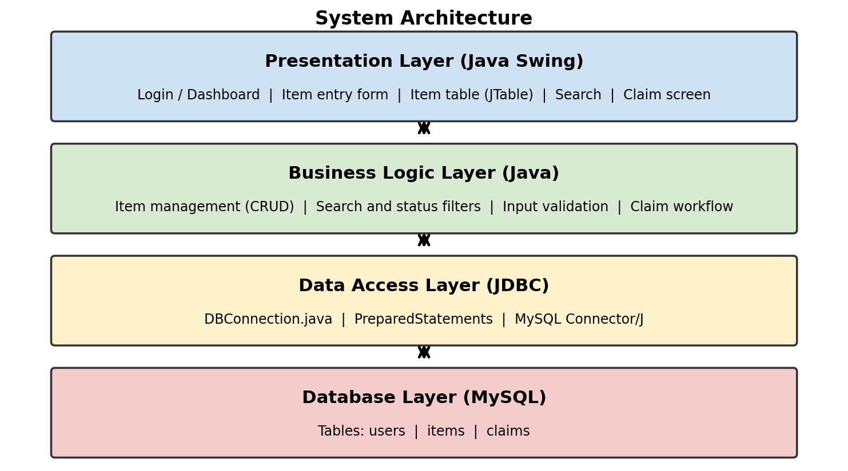
Figure 4.1: System architecture

4.2 ER Diagram
The database has three tables. A user can report many items, an item can have many claims, a user can submit many claims, and a user (administrator) can review many claims.
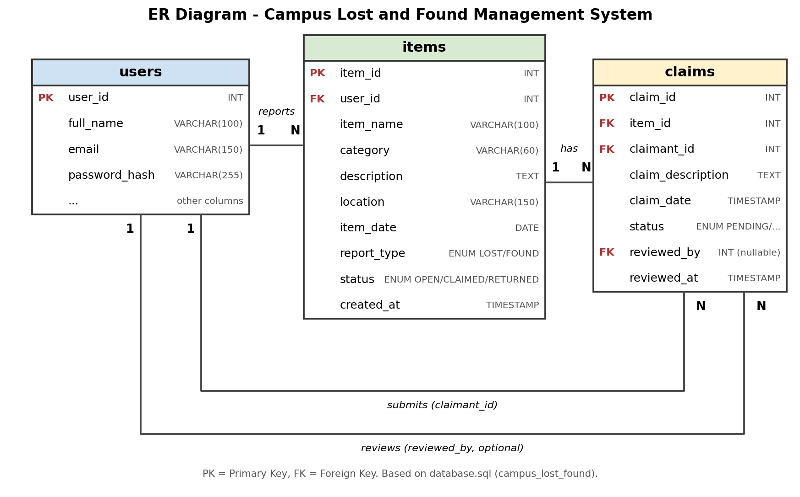
Figure 4.2: ER diagram
The diagram follows database.sql (database campus_lost_found). The users table has further columns that are not shown.

4.3 Claim Module
A user logs in and reports an item as Found (status Open). The owner finds it in the list, opens the Claim screen and submits a claim description as proof of ownership. The claim stays Pending and the item becomes Claimed. An administrator then reviews the claim. An approved claim marks the item as Returned, and a rejected claim sets the item back to Open.
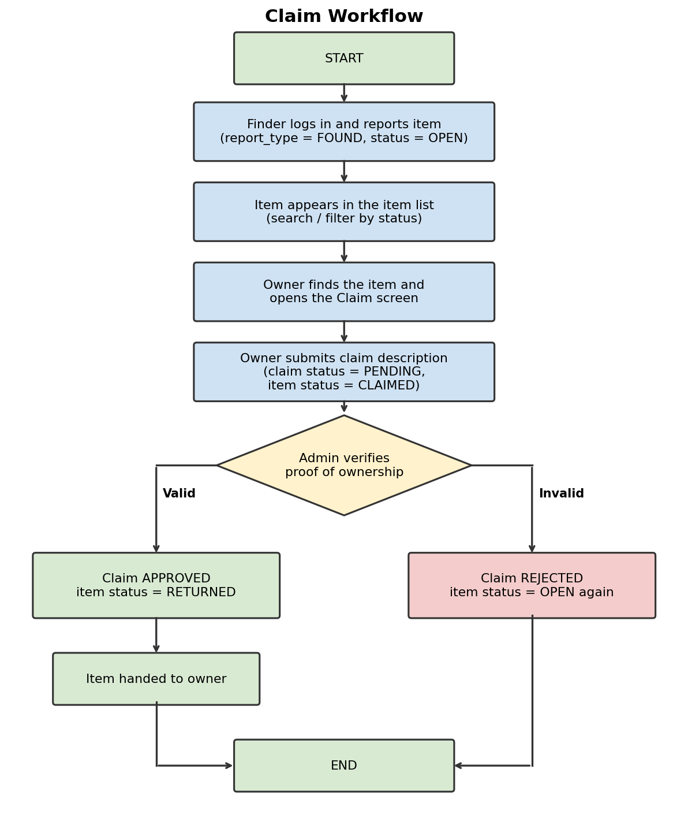
Figure 4.3: Claim workflow
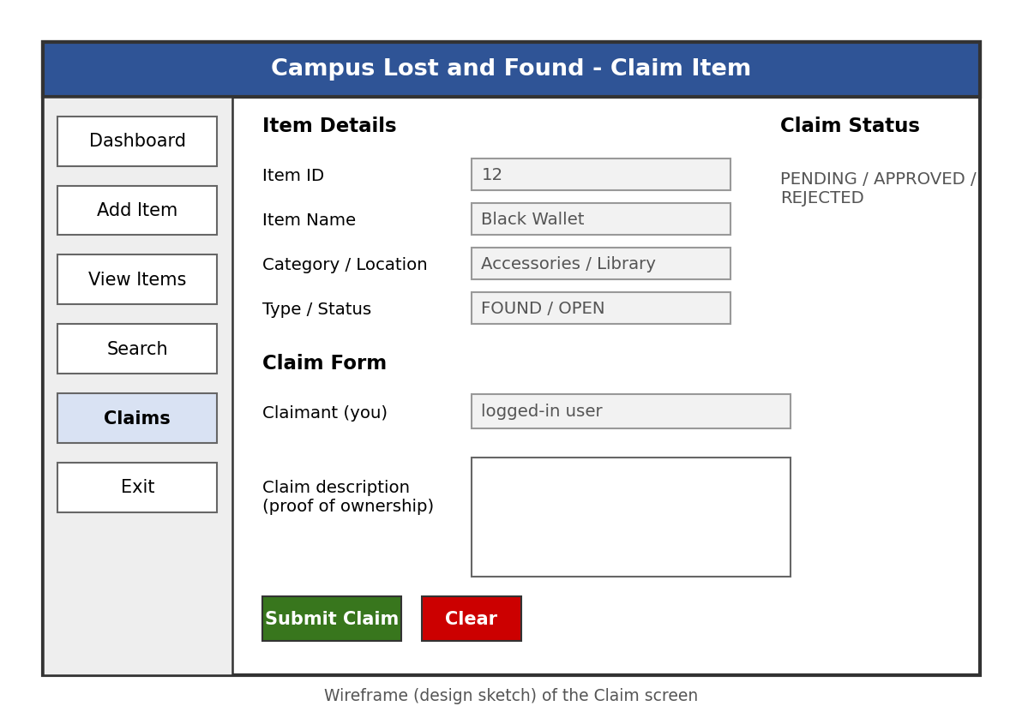
Figure 4.4: Claim screen design

5. Implementation and Screenshots
This chapter will be completed once the application is running. Each screenshot is added with a short caption.
- Database: tables created in MySQL with sample records [add screenshot]
- Main window and dashboard [add screenshot]
- Item entry form [add screenshot]
- Item listing table (JTable) [add screenshot]
- Search and status filter [add screenshot]
- Update and delete item [add screenshot]
- Claim screen [add screenshot]

6. Test Cases
The Actual Result and Pass/Fail columns are filled in during testing on October 19.
ID | Module | Input / Action | Expected Result | Actual Result | Pass/Fail
TC01 | Database | Run the application with MySQL running | Connection is established successfully
TC02 | Database | Run the application with MySQL stopped | A clear connection error message is shown; the app does not crash
TC03 | Login | Log in with a correct email and password | User is logged in and the dashboard opens
TC04 | Login | Log in with a wrong password | An error message is shown; access is denied
TC05 | Add item | Fill all fields with valid data and click Save | Item is saved with status Open and appears in the item table
TC06 | Add item | Leave the item name empty and click Save | Validation message is shown; nothing is saved
TC07 | Add item | Enter an invalid date format | Validation message is shown; nothing is saved
TC08 | View items | Open the item listing screen | All stored items are displayed in the table
TC09 | Update item | Select an item, change a detail and save | The record is updated in the table and in MySQL
TC10 | Delete item | Select an item and confirm deletion | The record is removed from the table and from MySQL
TC11 | Delete item | Select an item and cancel the confirmation | The record is not deleted
TC12 | Search | Enter a keyword that matches an item | Only matching items are shown
TC13 | Search | Enter a keyword that matches nothing | An empty list or a 'no items found' message is shown
TC14 | Filter | Select report type Found and status Open | Only Found items with status Open are shown
TC15 | Claim | Submit a claim description for an Open item | Claim is saved as Pending; the item status becomes Claimed
TC16 | Claim | Submit a claim with an empty description | Validation message is shown; no claim is saved
TC17 | Claim | Submit a claim for an item that is already Returned | The system rejects the claim with a message
TC18 | Review claim | Administrator approves a Pending claim | Claim becomes Approved, reviewer and review time are saved, item becomes Returned
TC19 | Review claim | Administrator rejects a Pending claim | Claim becomes Rejected and the item goes back to Open

7. Conclusion and Future Scope

7.1 Conclusion
The Campus Lost and Found Management System gives the campus one organised place to record lost and found items, search them and manage claims. It replaces notice boards and messages with a database-backed desktop application. The final results will be added after testing.

7.2 Future Scope
- A web or mobile version so that users can report and search items from anywhere.
- Email or SMS alerts when a matching item is found or a claim is approved.
- Photo upload for items, and image matching to suggest possible matches.
- Role-based login for students, staff and administrators.

